SIMATS ENGINEERING ASSESSMENT TOOL 3

COURSE NAME: Artificial Intelligence COURSE CODE: CSA17

COURSE OUTCOME COVERED

CO2: Experiment search and game-solving techniques such as Greedy Search, A*, CSP, Minimax, and Alpha-Beta pruning with heuristic functions for solving complex AI problems efficiently. (BL3)

Assessment Tool Weightage: 50%

Duration : 30 Minutes
QUESTIONS: 20 Total Marks:20

Annexure A

MCQ Test

Code of Conduct:

I THODETI DEEPESH( 192511464) (Name / Reg No) certify that this submission is my original work and that I have adhered to the guidelines specified for this assessment.
I understand that any violation of academic integrity rules will result in disciplinary action.

Signature of the student:
THODETI DEEPESH

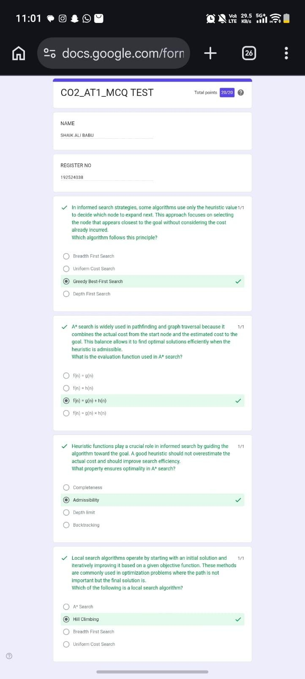

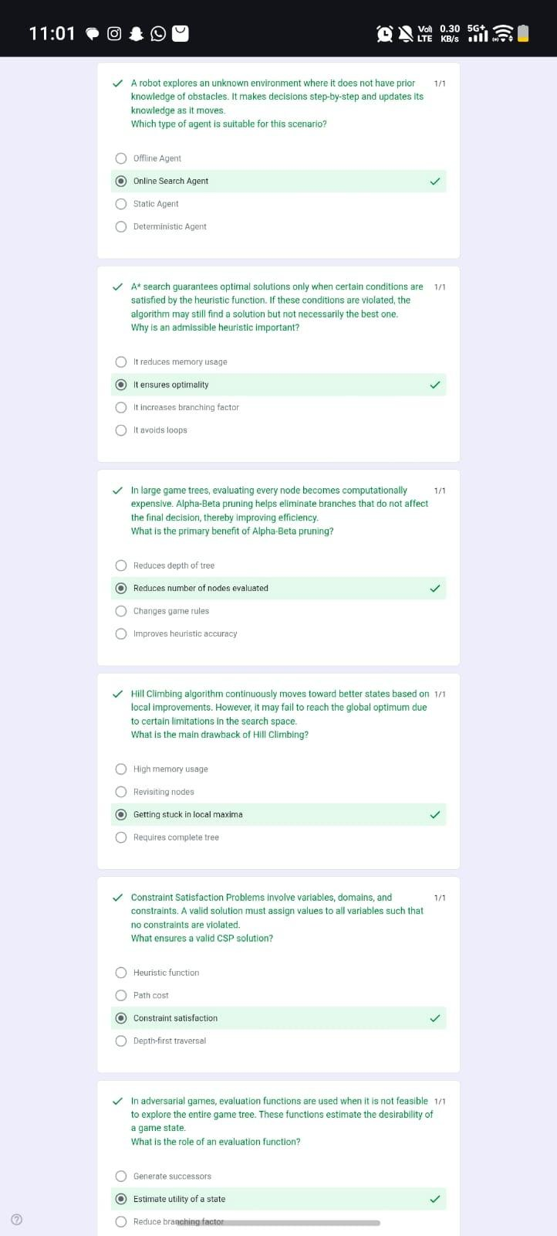

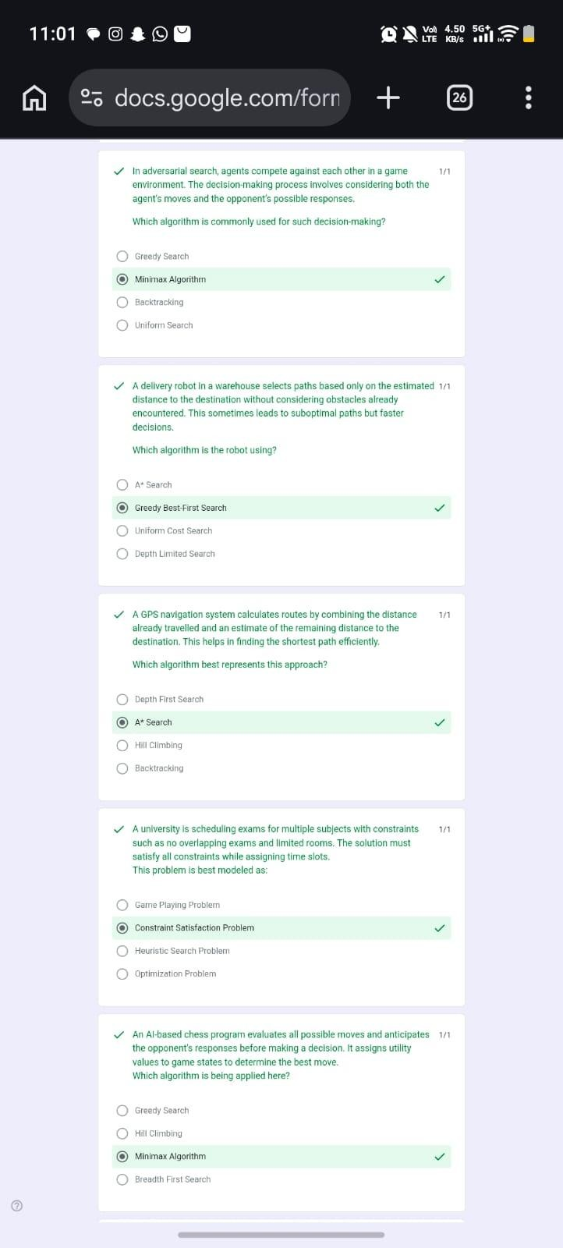

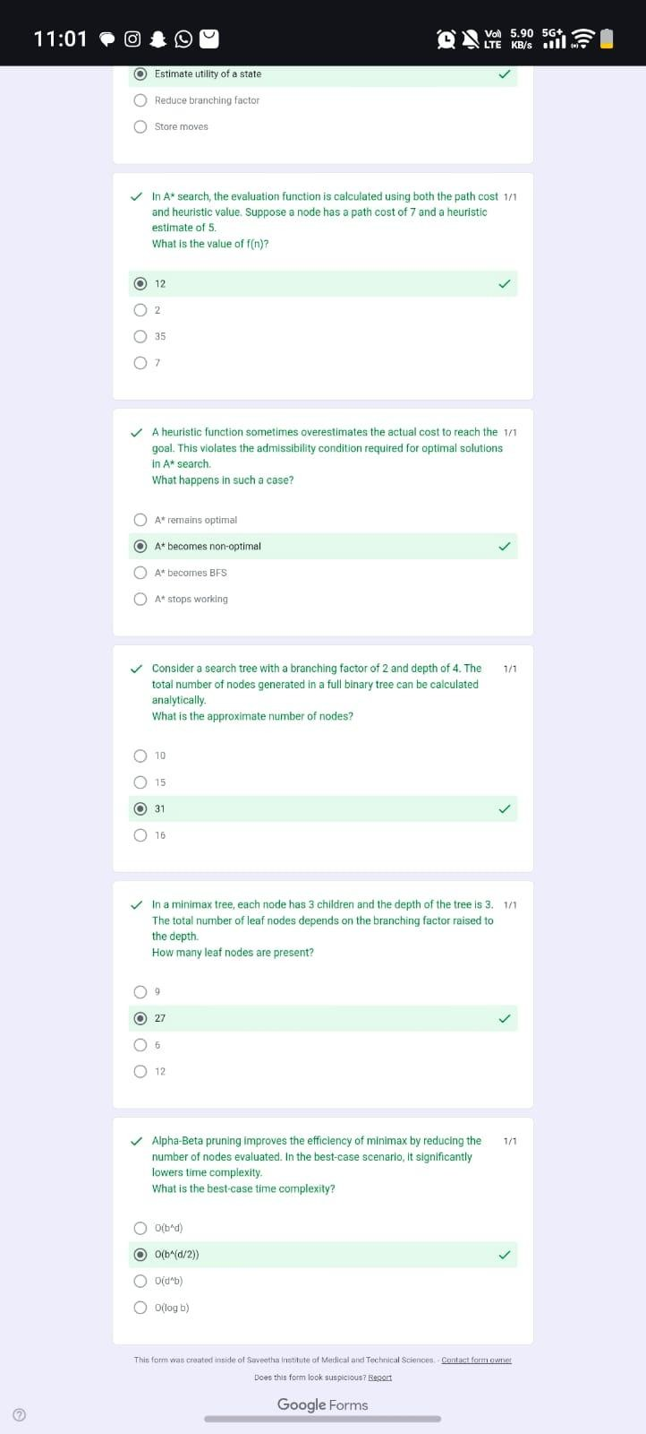

Criteria | Weight age (%) | Level 4  (Exemplary) | Level 3  (Proficient  ) | Level 2  (Developin g) | Level 1  (Beginning)
Conceptual Understandi ng | 30% | Demonstrates thorough understandin g; answers all questions accurately | Shows good understandi ng with few errors | Partial understandi ng; several incorrect responses | Lacks understandi ng; majority of answers incorrect
Accuracy of Answers | 25% | All answers are correct | Most answers are correct with minor mistakes | Some correct answers; frequent  errors | Mostly incorrect answers
Application of Knowledge | 20% | Correctly applies concepts to problem-base d questions | Applies concepts with minor errors | Limited ability to apply concepts | Unable to apply concepts
Time Managemen t | 15% | Completes quiz  well  within time efficiently | Completes on time with minor delays | Requires extra time or rushes through  questions | Unable to complete within given time
Question Interpretati on | 10% | Interprets all questions correctly and responds appropriately | Misinterpre ts a few questions | Often misinterpret s questions | Unable to understand questions

